Bridgepoint Parts Catalog

Section XXXVIII: FlexiPro Sprayer Page 1

NA0839

Barb 1/4” x 1/8” MPT Plastic

AP21

FloJet D3121V1311
50PSI Internal By-pass - 1.4GPM
12VDC motor
Viton Diaphragm & Check Valves

Valve Chamber: PF20914-002A
Upper Housing: PFDH31V131
Cam & Diaphragm Kit: PF21022-021A

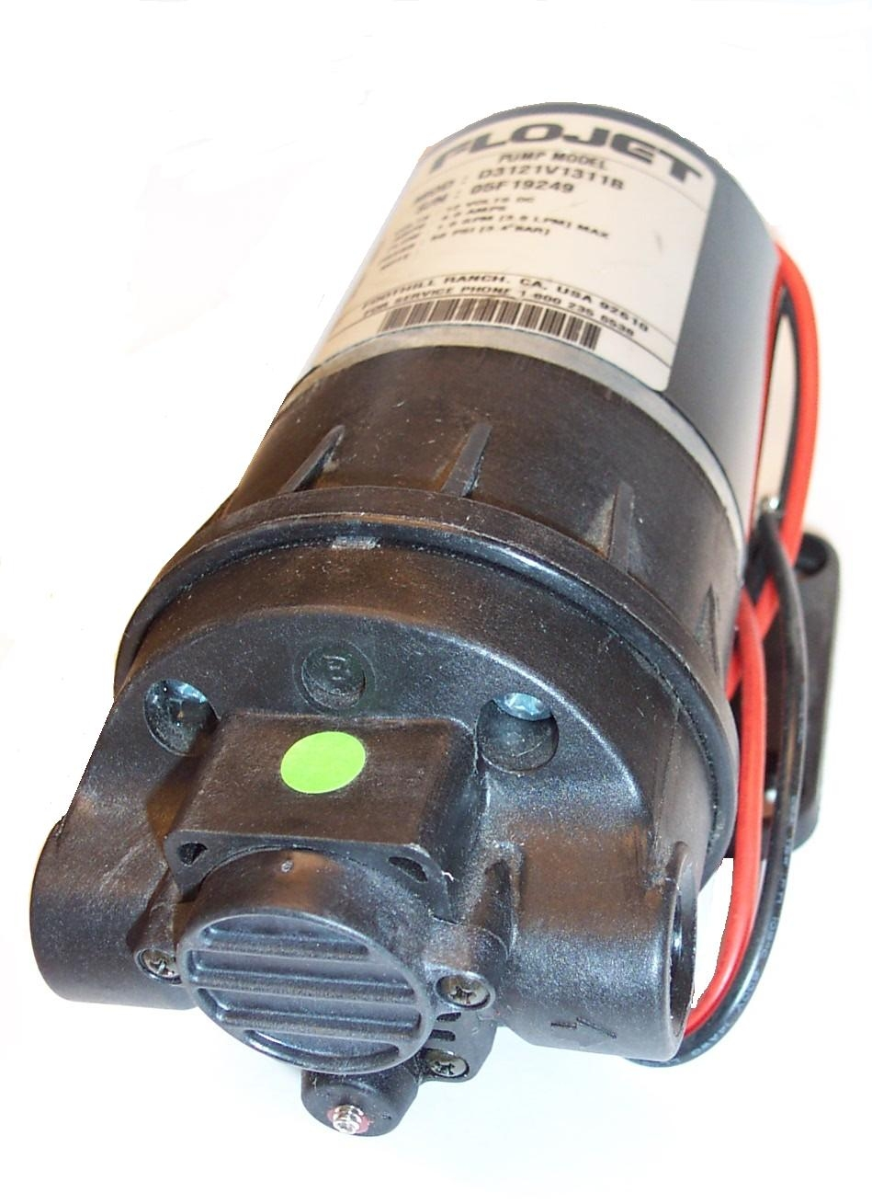
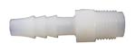

NA0840

Strainer – Acorn 1/8” FPT

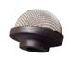

XAF1

Tubing 1/4” ID – Vinyl
Sold per inch
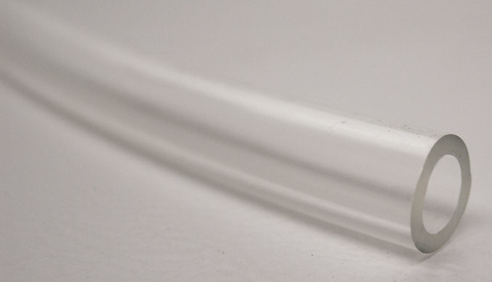

NS162

Elbow 90˚ - 3/8” MPT x 1/4” Barb

White Nylon
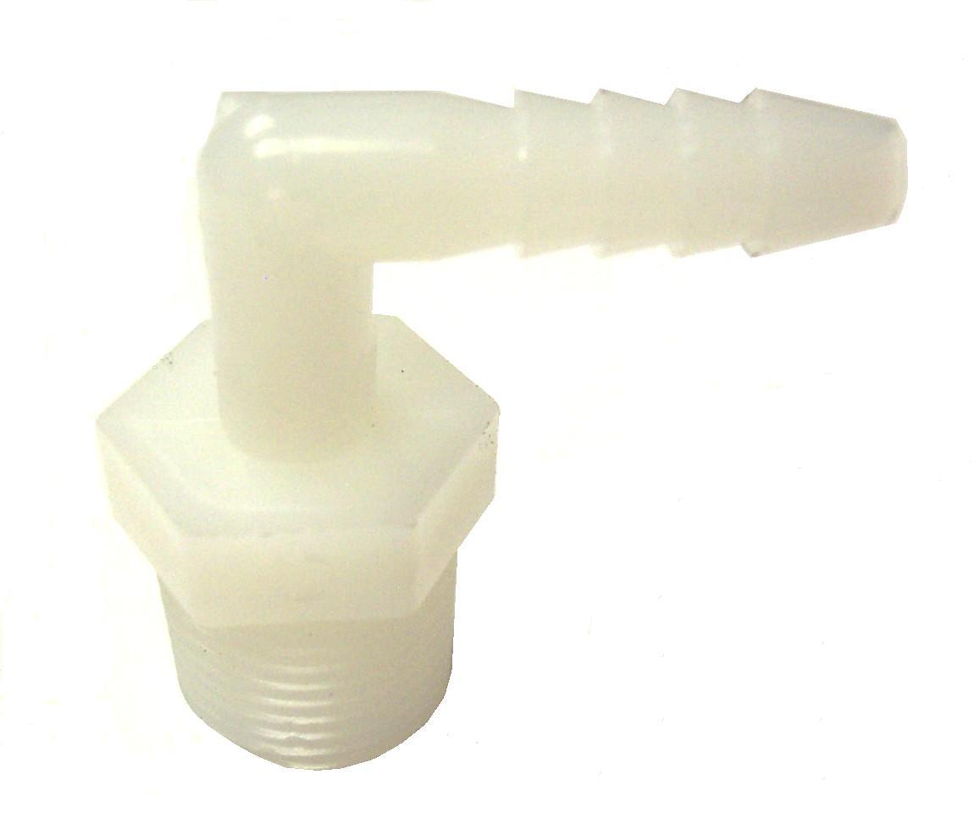

NM4102

Bottle 2.5 Gallon - Natural

Cap: NM4103
Grommet 3/8”: NM4116
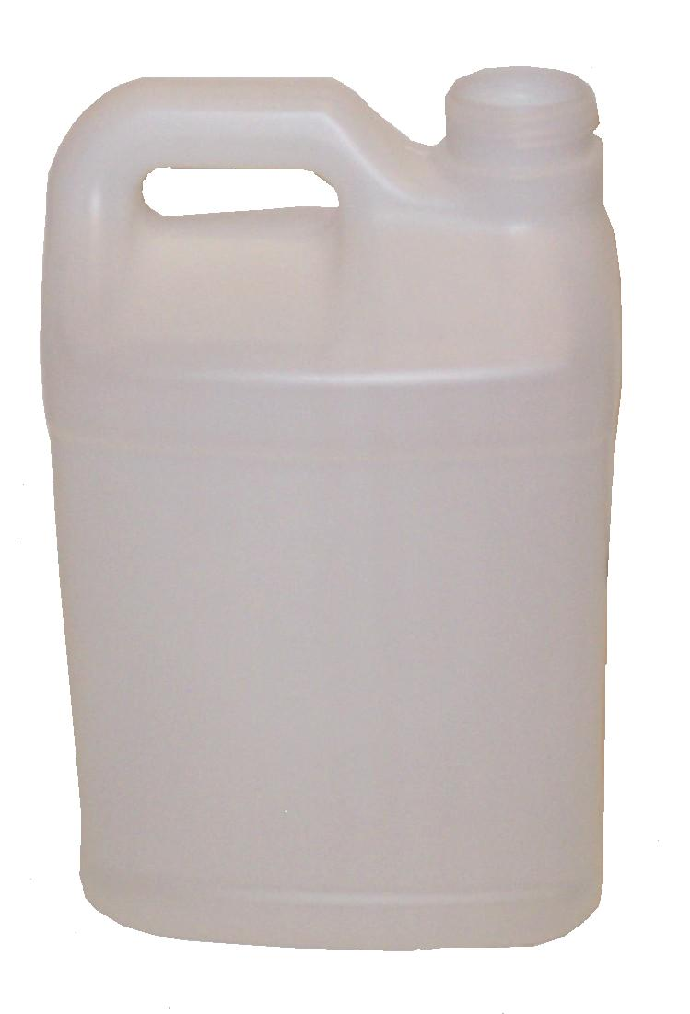

NM4114

Solution Hose 15’ - Coiled

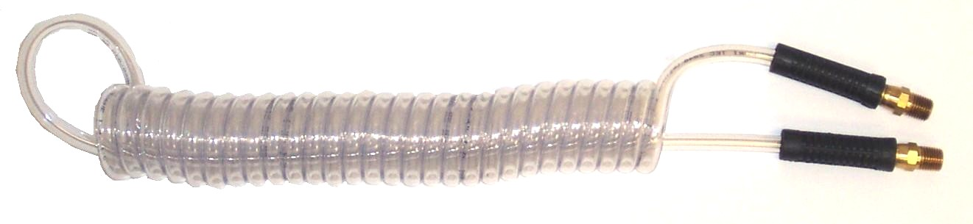

100010

Valve – Plastic Spray Gun
7GPM - 2600PSI

Repair Parts:
Valve: NA031
Rebuild Kit: NA031A

NM4113

Roto-Molded Body – Blue

FlexiPro Sprayer

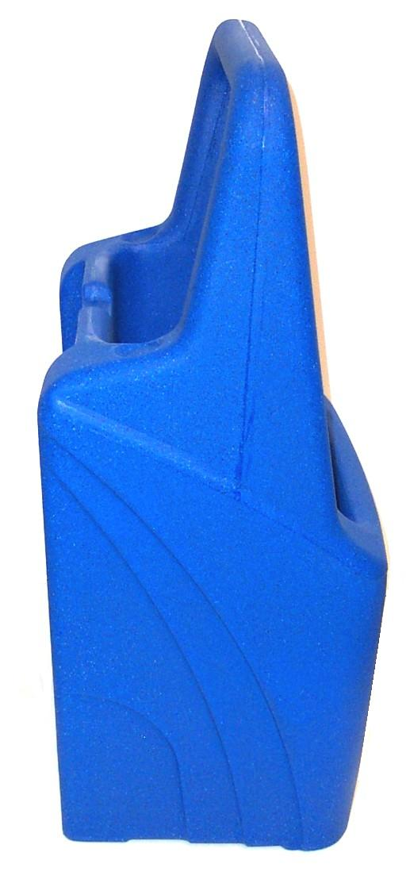

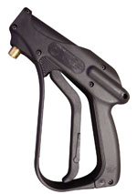

NA0802

Body – Strainer / Jet

1/4”MPT - Brass

NA0803

Strainer

NA0833

Extension 18” Stainless Steel
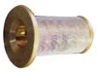

B281

VeeJet 8005 – Brass

1/4” FPT

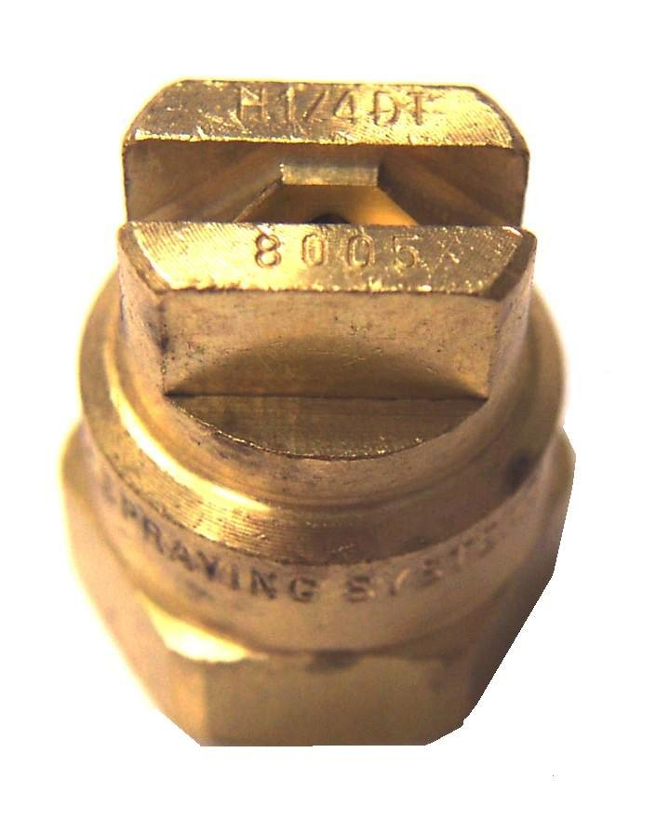
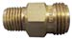

B006

Tee Jet 6501 Brass

NA0826

Cap Jet Retainer - Brass

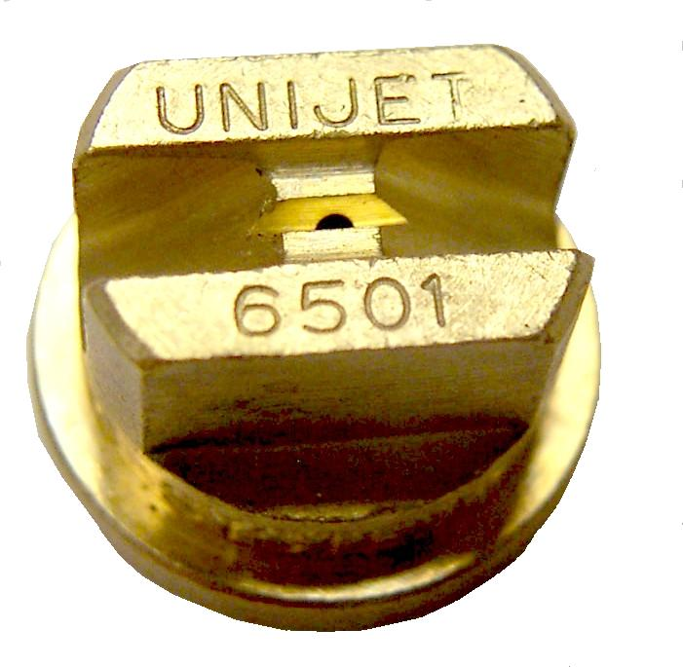
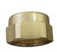

BR112

Coupler 1/4” F-F Brass

BR335

1/4"Male Quick Connect

Flo-Thru – Brass 1/4” FPT
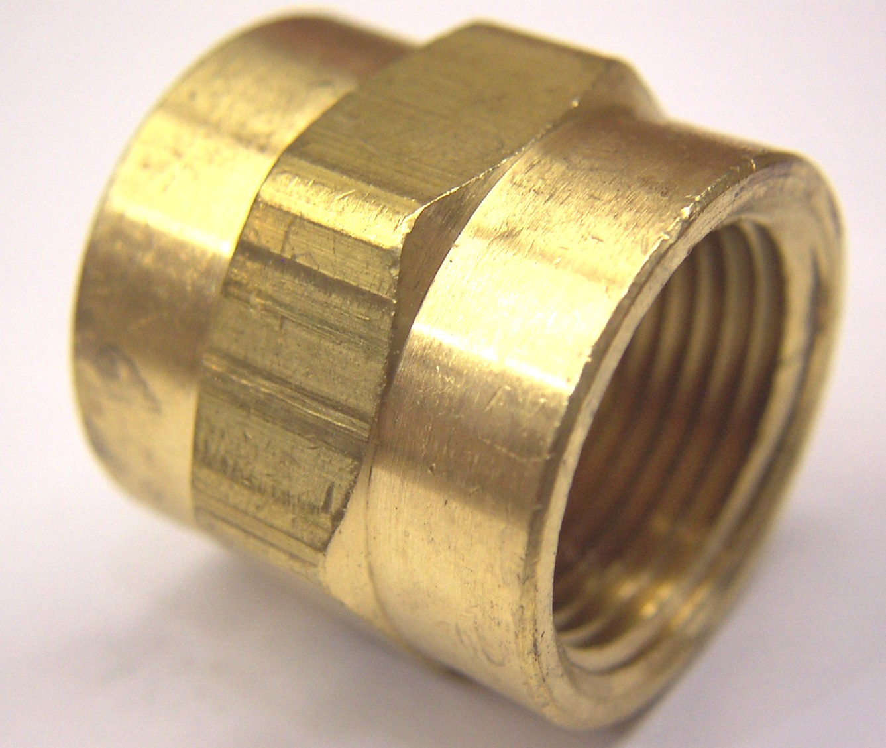
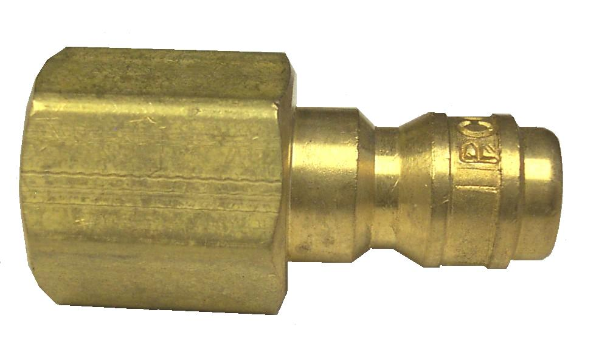

BR337

1/4"Female Quick Connect

Flo-Thru – Brass 1/4” MPT

NS123

Hose Clamp 3/8”
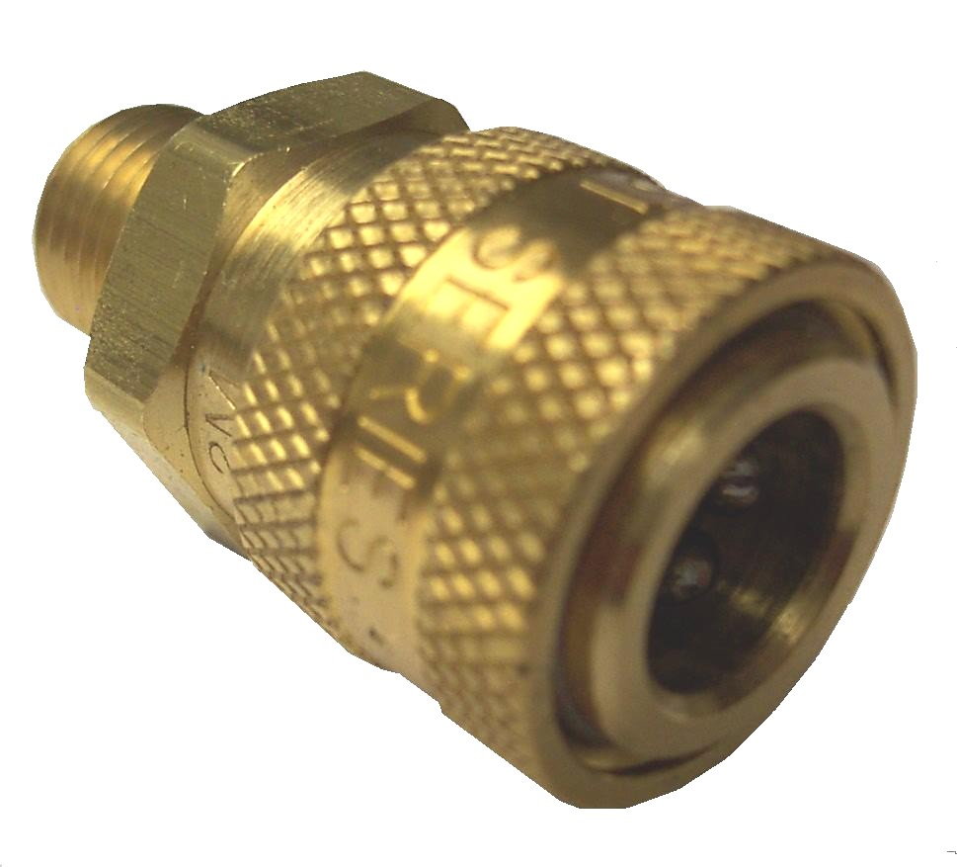
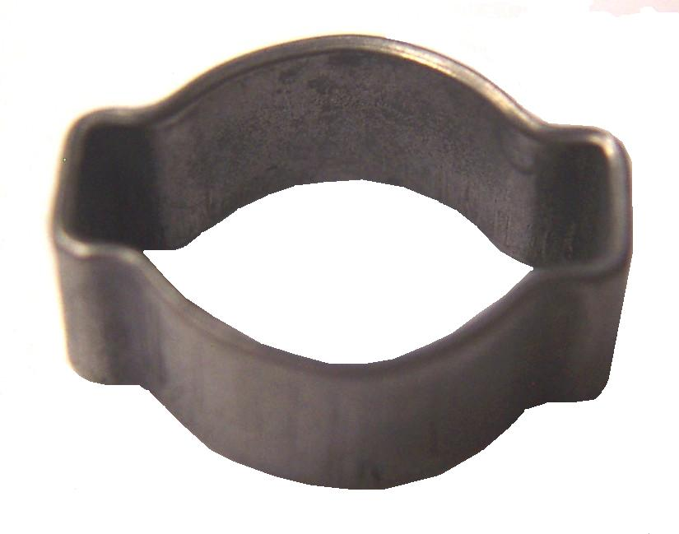

Bridgepoint Parts Catalog

Section XXXVIII: FlexiPro Sprayer Page 2

NM4100

Battery 12 volt – 8 amp/hr

FlexiPro Sprayer

NS126

Power Jack - FlexiPro

Square 3-Prong

DISCONTINUED
USE NS125
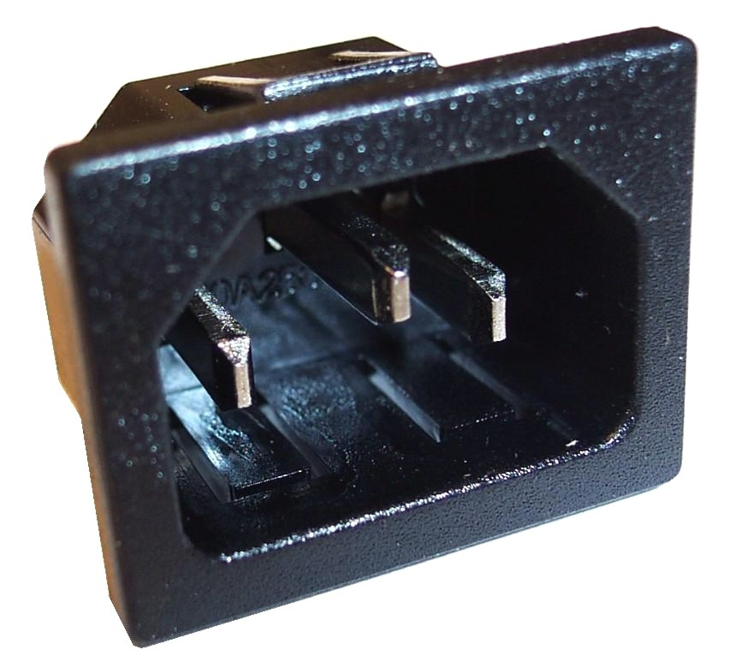
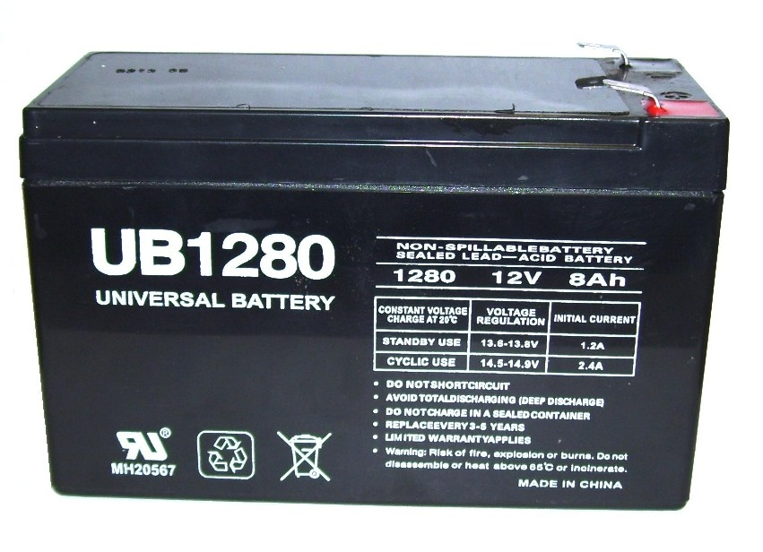

NS125

Power Jack W/ Bezel

Square 3-Prong – New Style

PK6A10

Diode 6 amp – 12 volt
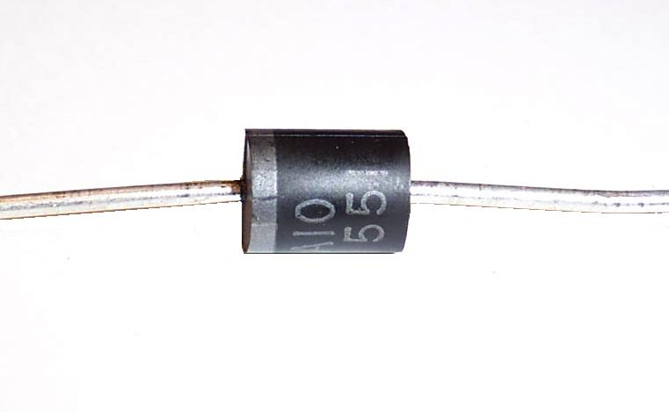
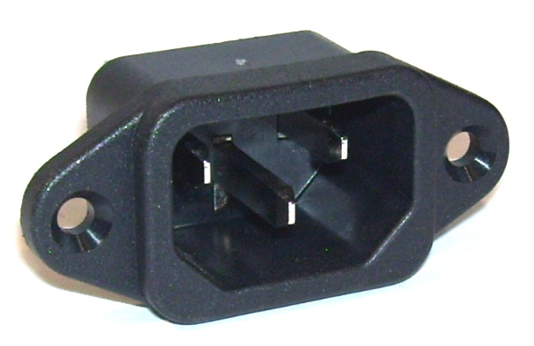
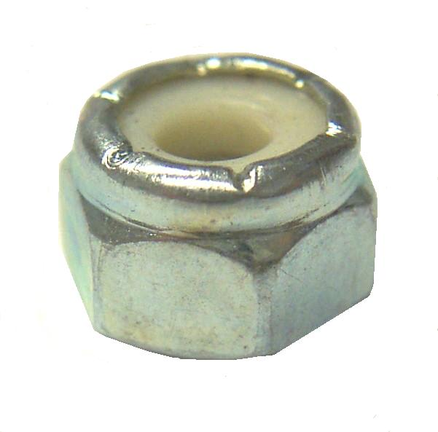

PLF-AGC10

Fuse 10 amp AGC

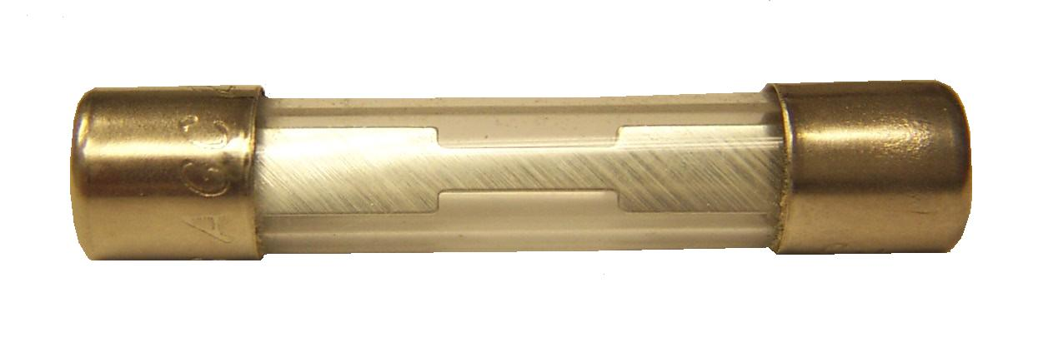

NM4123

Screw 6-32 x 1/2”

Phillips Flat Head - SS

NM4031

Nut 6-32 Hex Nylock SS

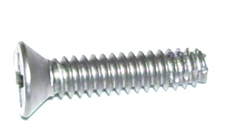

NS177

Fuse Holder

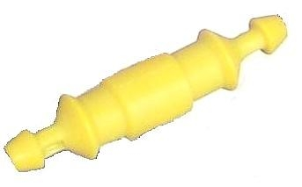

NM4111

Rocker Switch - FlexiPro

SPST

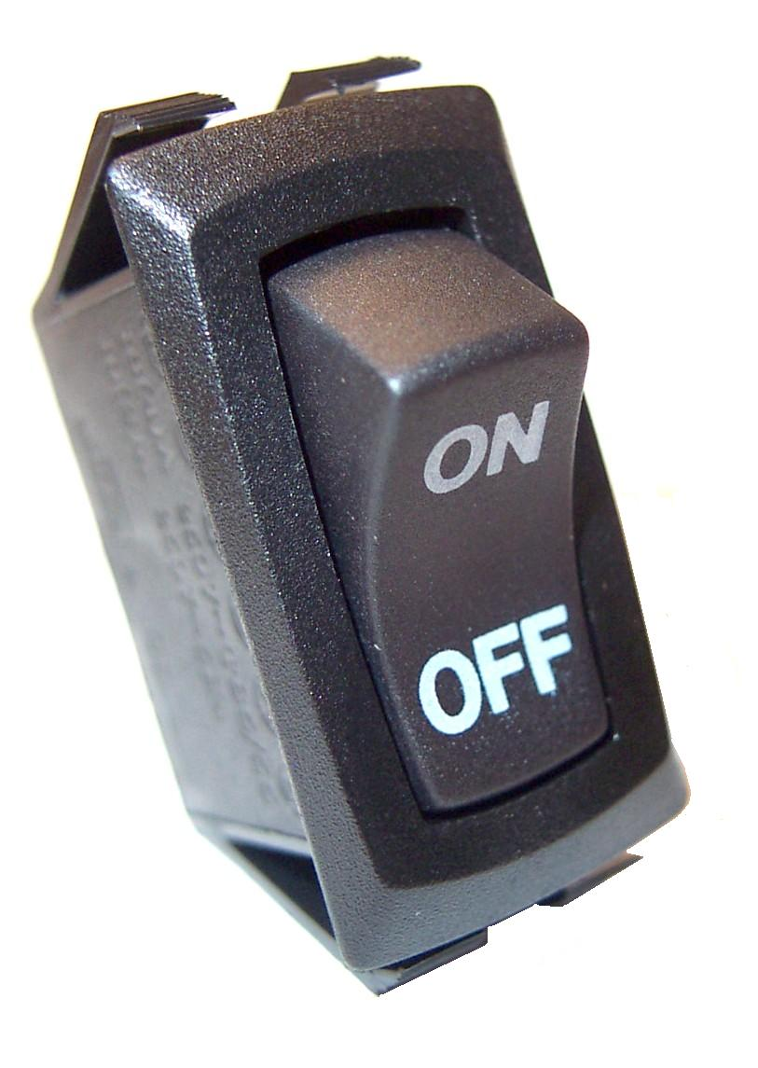

NM4106

Base Plate – FlexiPro Sprayer

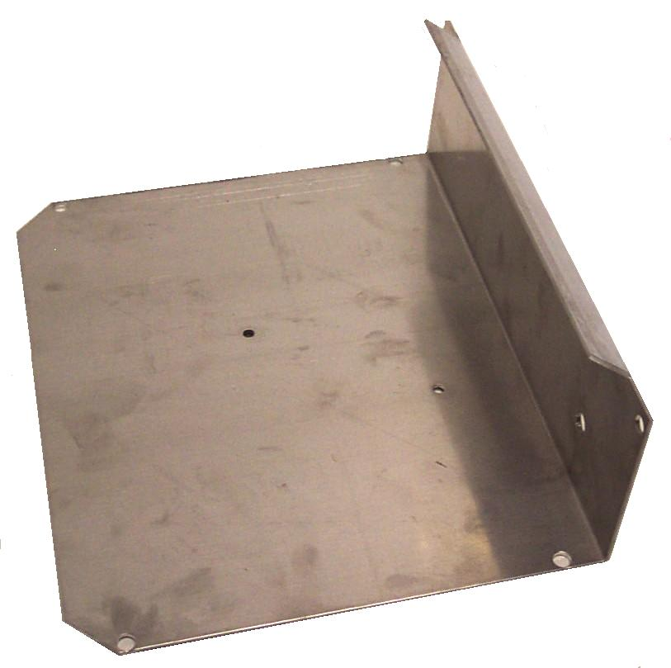

NM4115

Screw 10-32 x 1-1/4”

Button Head Socket - SS
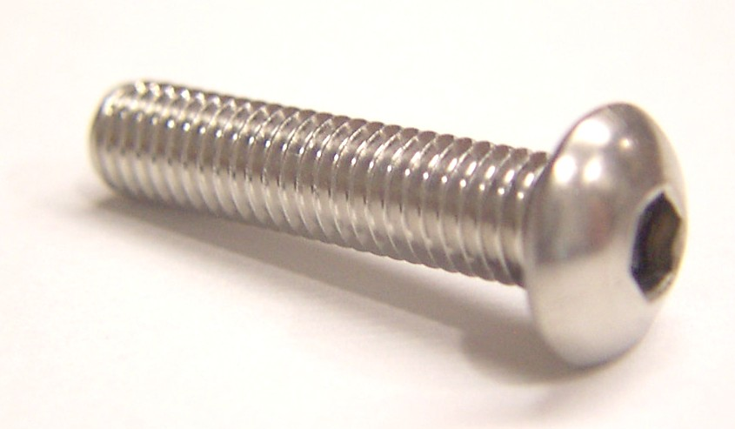

NM4112

Power Jack - FlexiPro

12 volt – Round - Old Style

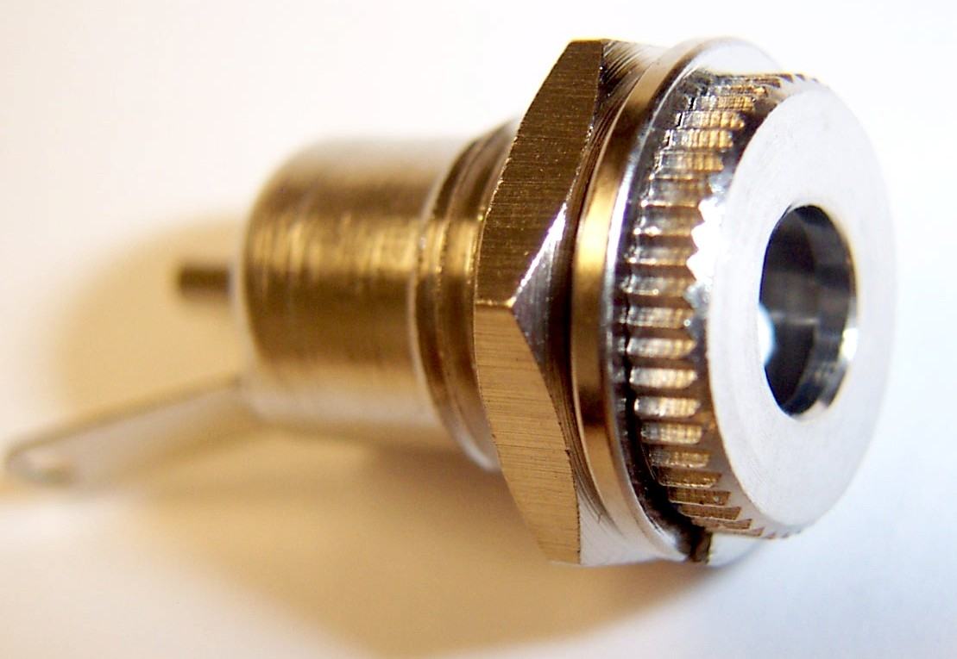

NM4116

Grommet – 3/8”
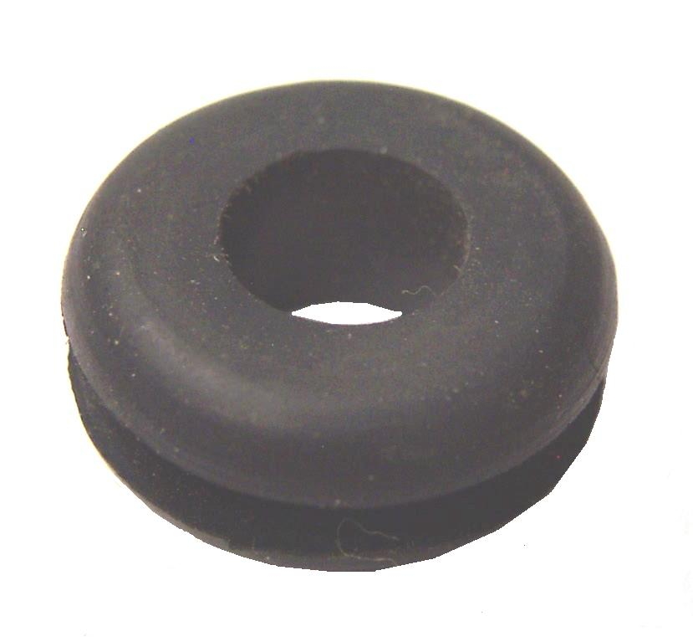

NM4104

Axle Cap – 3/8”

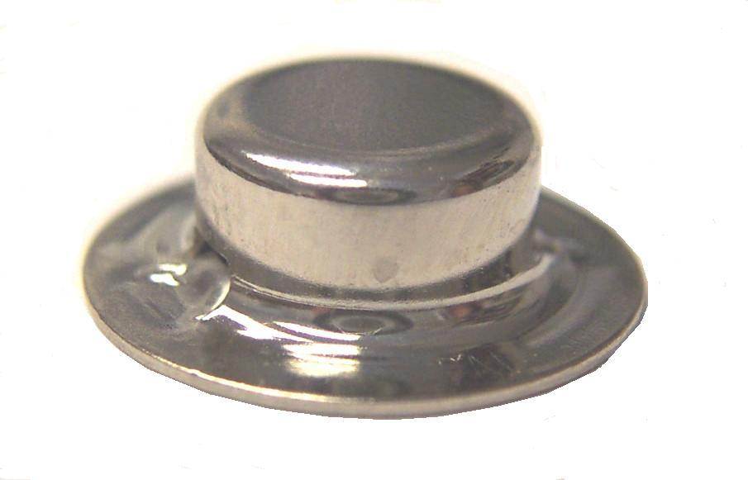

NM4117

Grommet – 3/4”

NM4081

Nut 10-32 Hex Nylock SS
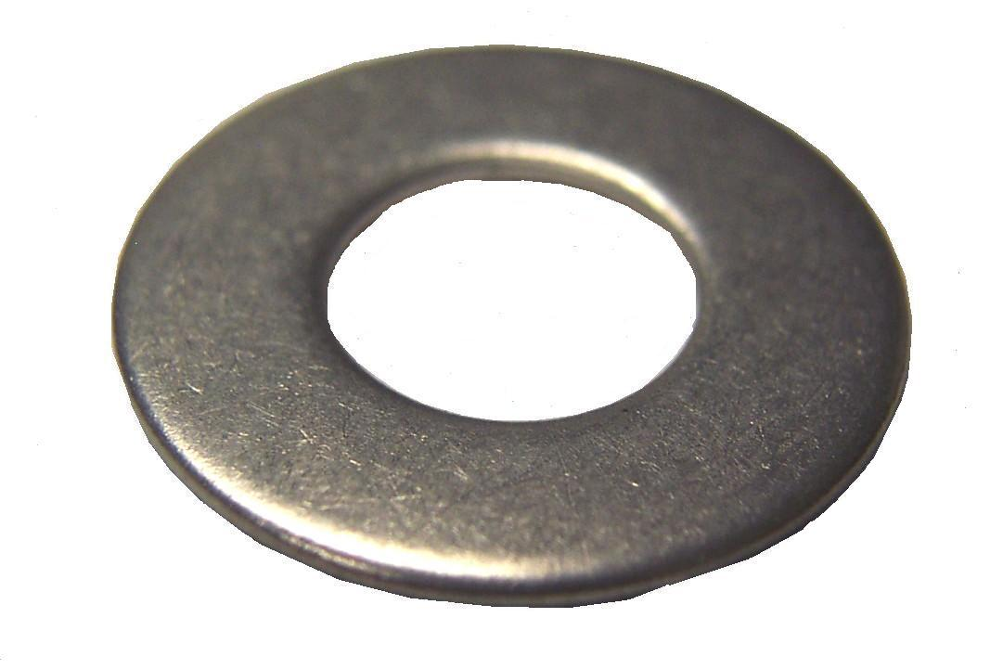
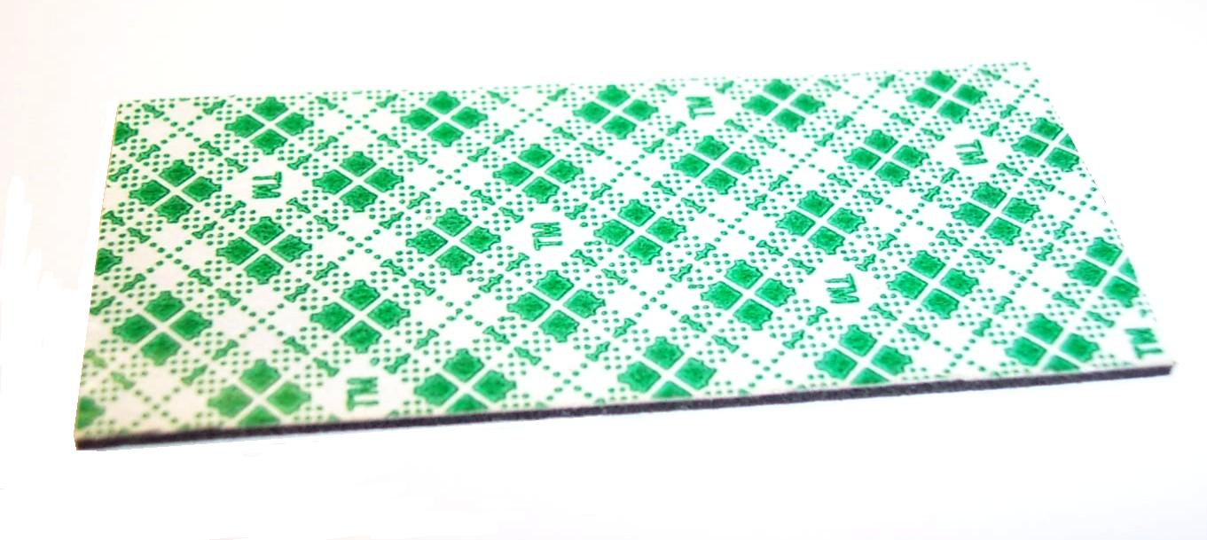
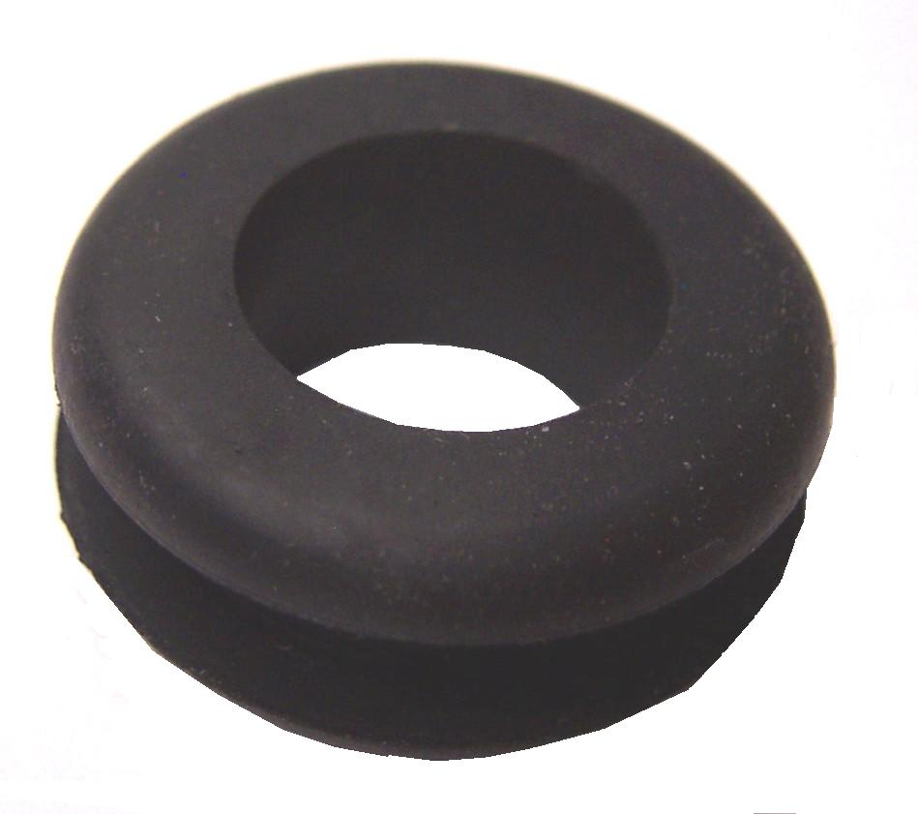

XHA07

Aluminum Rod 3/8”
Sold Per Inch

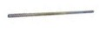
16.75” for Sprayer Axle

NM4105

Wheel 6” –FlexiPro Sprayer
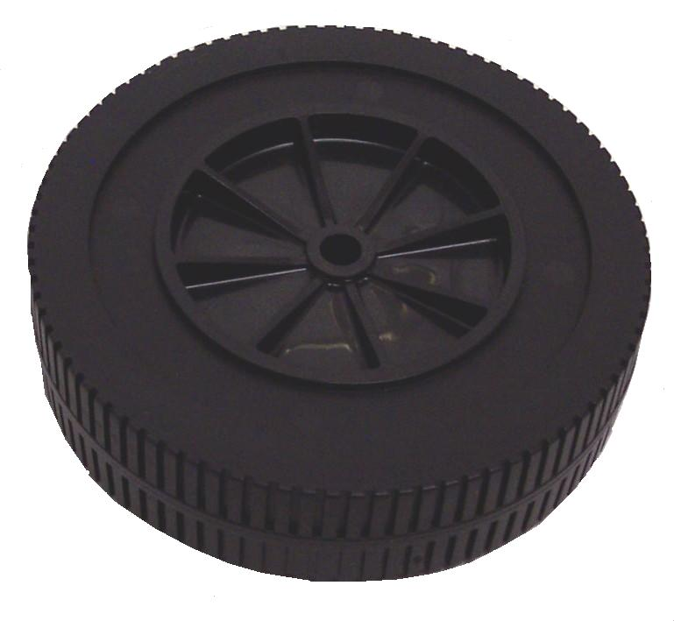

NM4064

Washer Spacer 7/16” x 7/8”

NM4110

Extendable Handle – FlexiPro

New Style 5-3/4” wide

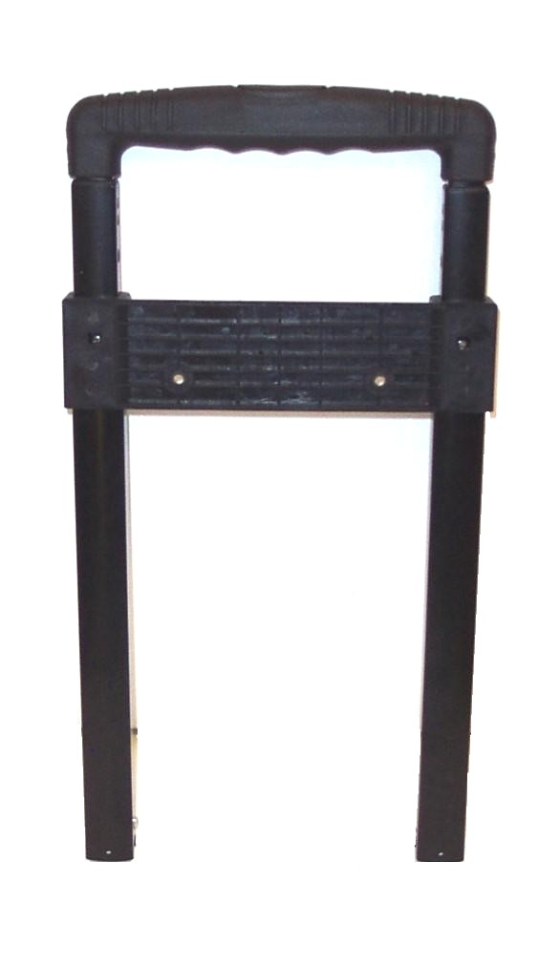

NM4074

Double Stick Tape 3M VHB
Sold Per Inch

NM4107

Extendable Handle

Old Style – Omni Pro 8.5” wide
DISCONTINUED USE NM4110

NM5033

Washer Motor Manifold Bolts

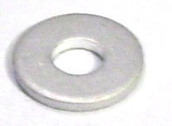

Bridgepoint Parts Catalog

Section XXXVIII: FlexiPro Sprayer Page 3

NS174

Fuse 1 amp AGC
Used in 115VAC sprayers only

AP31

FloJet D3631V1311
45PSI Internal By-pass - 1.50GPM
115VAC motor
Viton Diaphragm & Check Valves

Used with 115VAC sprayers only
Repair Parts:
Valve Chamber: PF20914-002A
Cam & Diaphragm Kit: PF21022-022A
Upper Housing: PFDH31V131

NS129

Power Cord – Detachable

Square 3-Prong Plug

Used with 115VAC sprayers only

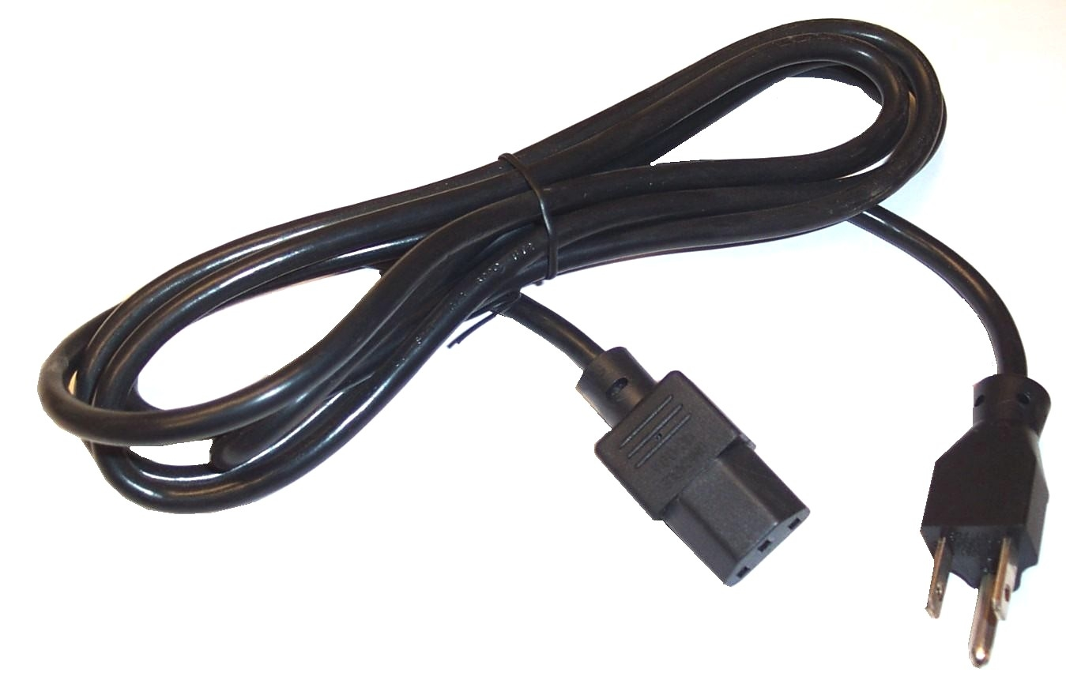

NM4109

Car Charger 12 Volt – Round Tip

Cigarette Lighter Plug

NM4108

Charger 110 Volt to 12Volt

Wall Plug

Round Plug End
DISCONTINUED – USE NM4119

UNREGULATED TRANSFORMER CHARGER

NM4108A

Charger 110 Volt to 12Volt

Wall Plug

Square 3-Prong Plug End

DISCONTINUED – USE NM4108B

UNREGULATED TRANSFORMER CHARGER

NM4108B

Charger 110 Volt to 12Volt

Wall Plug

Square 3-Prong Plug End

SWITCHMODE TAPER CHARGER

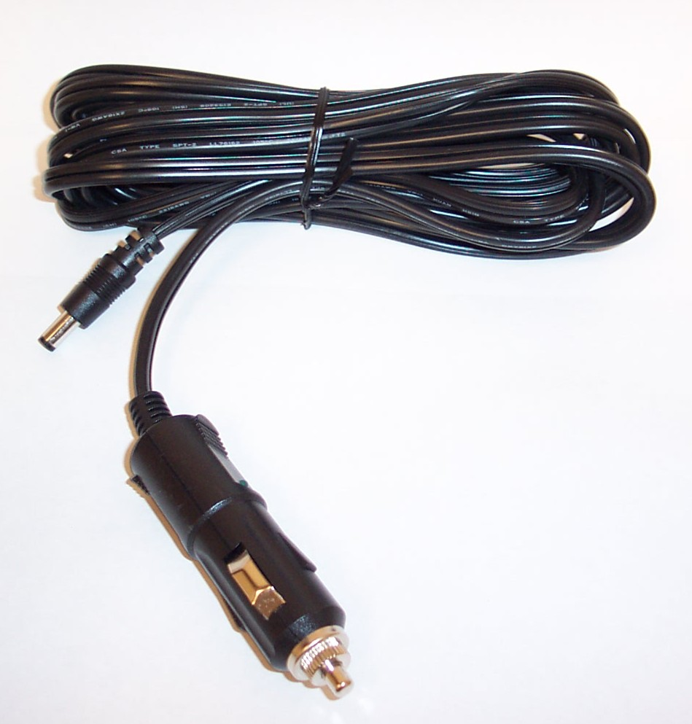

NM4118

Adapter w/ Alligator Clips

For Cigarette Lighter Plug

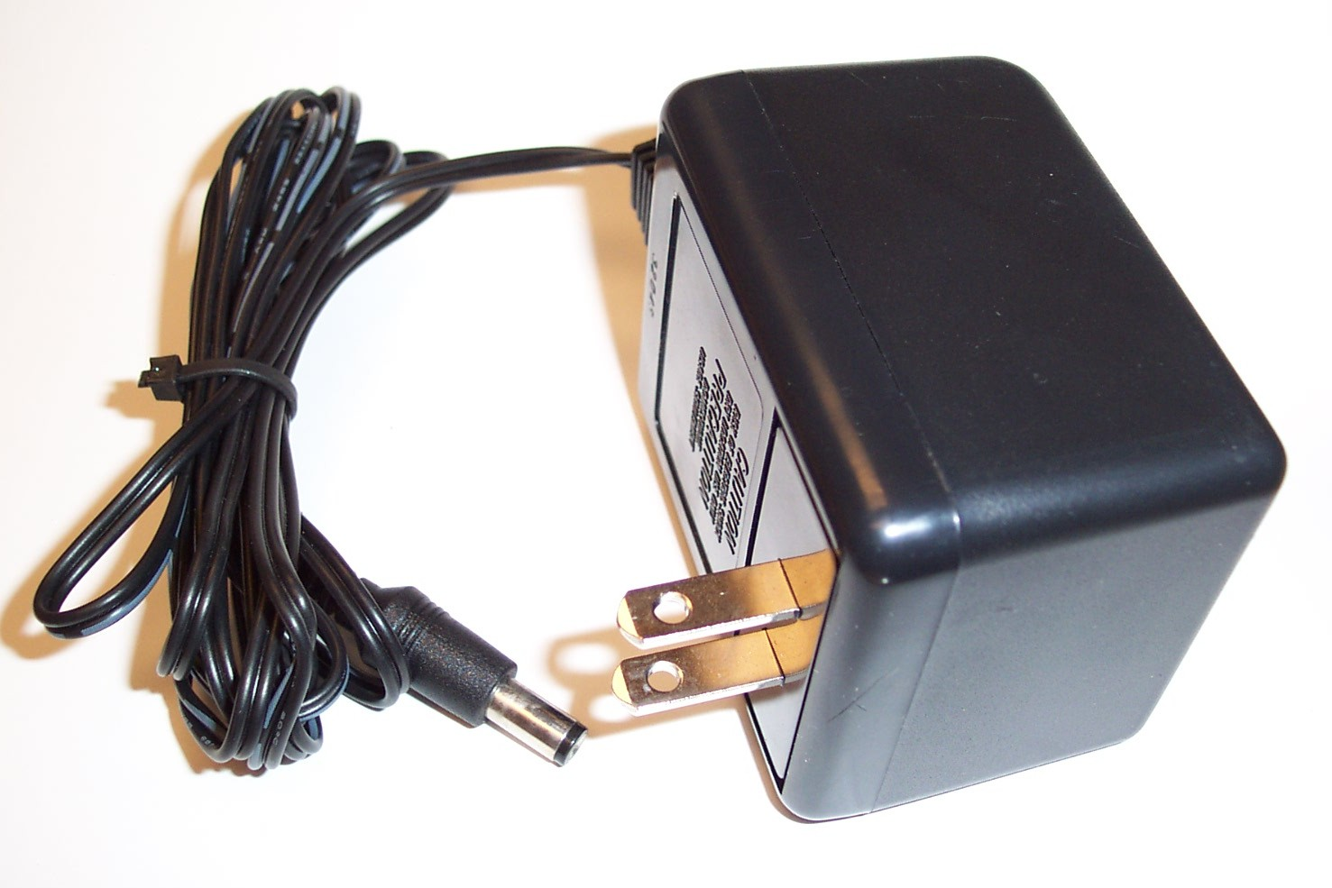
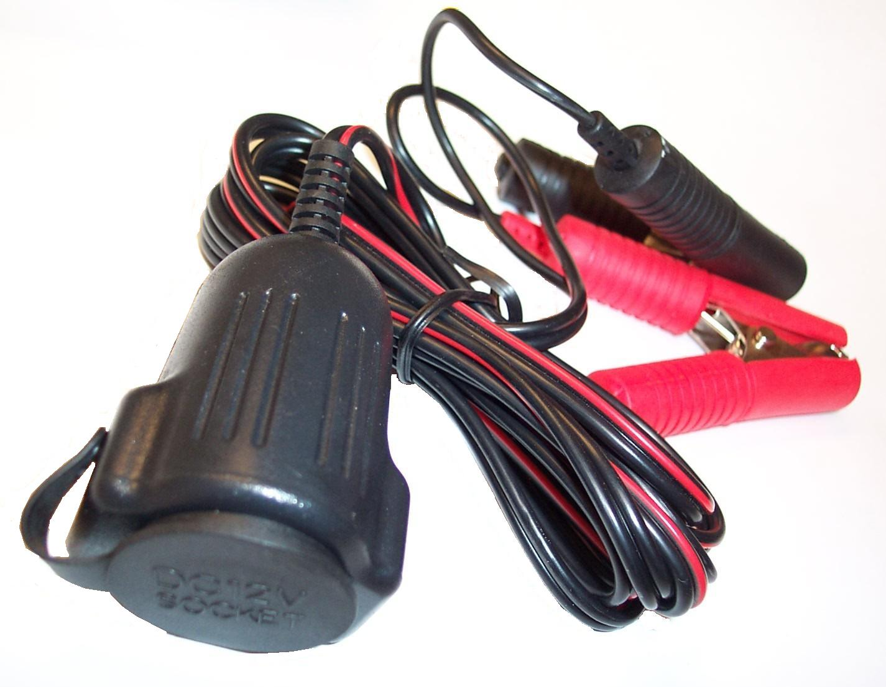

NM4119

Charger 110 Volt to 12Volt

Wall Plug

Round Plug End

SWITCHMODE TAPER CHARGER

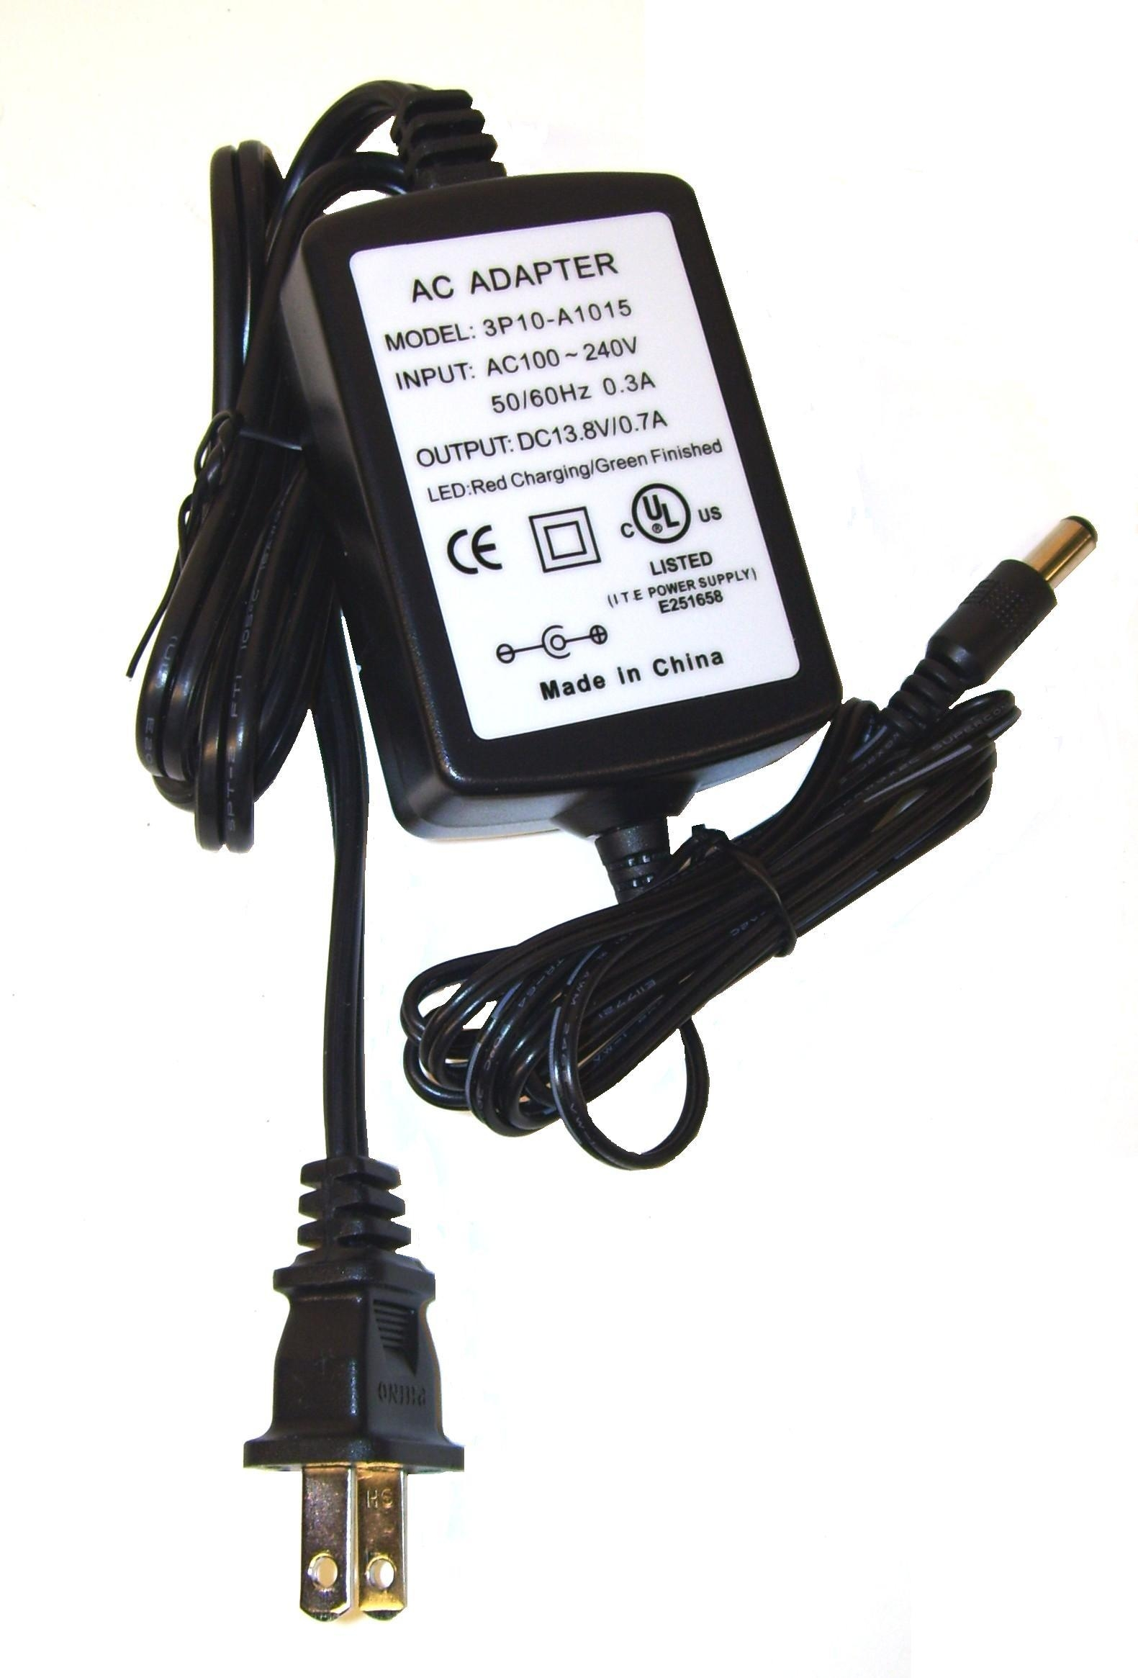
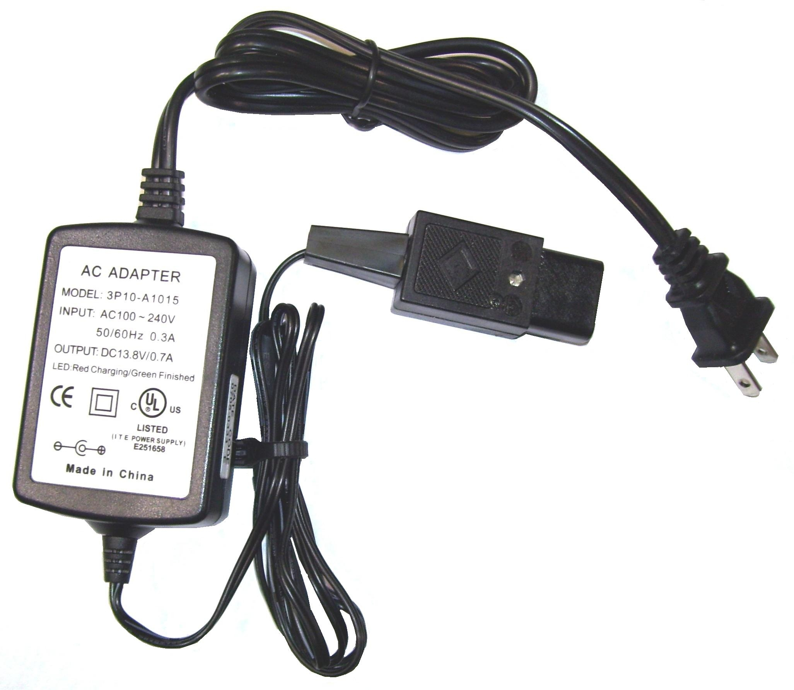
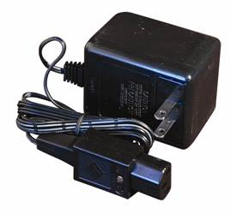

NM4109A

Car Charger 12 Volt

Square Plug

Cigarette Lighter Plug

